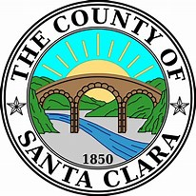

CONFLICT RESOLUTION SERVICES – EQUAL OPPORTUNITY DIVISION
We support the development of healthy conflict resolution practices on individual, interpersonal, and institutional levels for all County staff.
Conflict Resolution Services (CRS) supports harmonious work environments, where we can be happier, healthier, and more productive within our roles as a team.
All CRS Services are free to County Employees. CRS offers:
- COACHING:

- Executive coaching
- Individual coaching for staff experiencing interpersonal conflicts at work
- Consultations with directors, managers, and supervisors regarding conflicts

- FACILITATED DIALOGUE:
CRS facilitates dialogue between two or more parties with a goal of achieving a harmonious workplace; and, where appropriate, can provide support to parties at the conclusion of an investigation.
- TRAINING:

CRS offers training to individuals and groups regarding conflict resolution skills, building a harmonious work environment, and other CRS topics.
- DEPARTMENTAL ENGAGEMENT (TEAM BUILDING)
CRS offers ongoing coaching and teambuilding support for County departments experiencing high levels of interpersonal conflict with or across teams.

Through the CRS process, tension is reduced, issues get resolved, relationships are strengthened, and workplaces become more harmonious. If you, or people you work with, have a need for our services, please contact us at: CRS@eod.sccgov.org or (408) 993-4840.

